**BJT BIASING CIRCUITS VOLTAGE-DIVIDER BIAS CONFIGURATION**

**Lab No: 10**



**Spring 2021**

**CSE-206L Electronic Circuits Lab**

Submitted by: **Ashfaq Ahmad**

Registration No: **19PWCSE1795**

Class Section: **B**

“On my honor, as student of University of Engineering and Technology, I have neither given nor received unauthorized assistance on this academic work.”

Student Signature: ______________

Submitted to:

**Eng: Abdullah Hameed**

**July** 10, 2021

**Department of Computer Systems Engineering**

**University of Engineering and Technology, Peshawar**

**Objectives:**

* To determine the quiescent operating conditions of the Voltage-Divider bias BJT configuration.

**Equipment:**

* DC Power Supply
* DC voltmeter
* DC Ammeter

**Components**

* Resistors: 33 k, 1.8 k, 6.8 k, 680.
* Transistors: 2N3904, 2N2222 or 2N4401

**Theory:**

* **Biasing of the bipolar junction transistor (BJT)** is the process of applying **external voltages** to it. In order to use the BJT for any application like amplification, the two junctions of the transistor CB and BE should be properly biased according to the required application. Depending on whether the two junctions of the transistor are forward or reverse biased, a transistor is capable of operating in three different modes.

**Cutoff Mode of BJT:**

* The BJT is fully off in this state. In the cutoff mode both the base emitter BE as well as collector base CB junction is reverse biased. The BJT is equivalent to an open switch in this mode.

**Saturation Mode of BJT:**

* The transistor is fully on in this state. The CB as well as BE junctions are forward biased. The BJT operates like a closed switch in the saturation mode. If a BJT is in saturation mode than it should satisfy the following condition,
* Where, βDC is common emitter current amplification factor or current gain.

**Active Mode of BJT**

* In order to use the transistor as an amplifier, it must be operated in the active mode. The BE junction is forward biased whereas the CB junction is reverse biased. Figure below shows both n-p-n and p-n-p transistors biased in the active mode of operation.

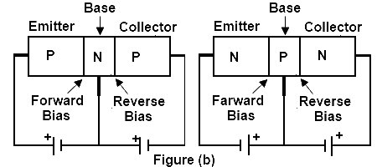

**Biasing Circuits of BJT**

To make the Q point stable different biasing circuits are tried. The Q point is also called as operating bias point, is the point on the DC load line (a load line is the graph of output current vs. output voltage in any of the transistor configurations) which represents the DC current through the transistor and voltage across it when no ac signal is applied. The Q point represents the DC biasing condition. When the BJT is biased such that the Q point is halfway between cutoff and saturation than the BJT operates as a CLASS-A amplifier. The three circuits or biasing arrangements which are practically used are explained below.

**Procedure:**

* Construct circuit as of *Fig.1* using 2N3904 transistor and set VCC = 20 V.
* Here another branch 6.8k is added to the circuit while this branch was not in lab 9.
* So first we will verify our Circuit either branch work correctly or not.
* We will verify this equation first **IB= IR1-IR2 .**
* Measure the voltages VCE. Record it in table. Here **VCE=VCC-IC(RC+RE)**
* **We** can also calculate VCE directly using voltmeter across collector and emitter.
* Calculate the resulting base current, IB and collector current, IC. Using the values obtained, find β.
* Now simply remove the 2N3904 transistor and replace with 2N4401 transistor.
* Again, measure the voltages VCE. Using the same Method, calculate the values of IB and IC. From the values obtained, determine the β value for 2N4401 transistor.
* Calculate the magnitude (ignore the sign) of the percent change in each quantity due to a change in transistors.

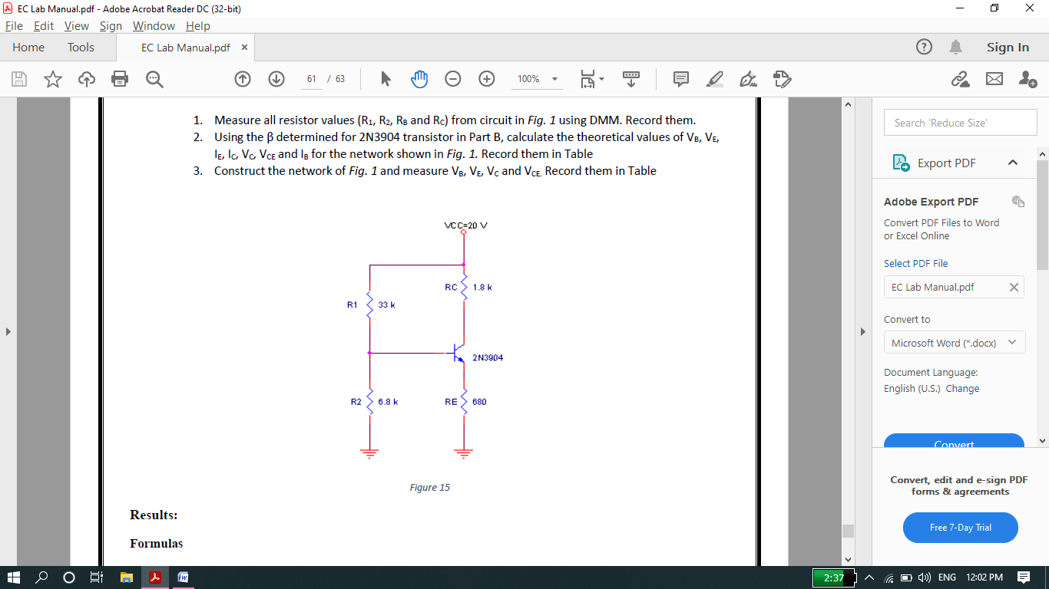

**Different Formulas:**

* **IB=VRB/RB=VCC-VBE/RB**
* **IC=VRC/RC=VCC-VCE/RC**
* **VCE=VCC-Ic(RC+RE)** only in this voltage-Divider circuit
* **VBE=VCC- VRB**
* **VRC=IC/RC**
* **VRB=IB/RB**
* **Alpha=IC/IE.**
* **Beta=IC/IB.**

**NOTE:**

* In proteus we calculate IB, IC VRC and VRB directly using DC Ammeter and DC voltmeter. But we can also calculate these parameters using above formulae.
* VBE is voltage across base and emitter terminals of transistor. Similarly VCE is the voltage across collector and emitter terminals of transistor. We can also calculate these values directly using DC voltmeter connecting across collector emitter and Base emitter.

**Formulae for finding Percent change Due to change in transistor:**

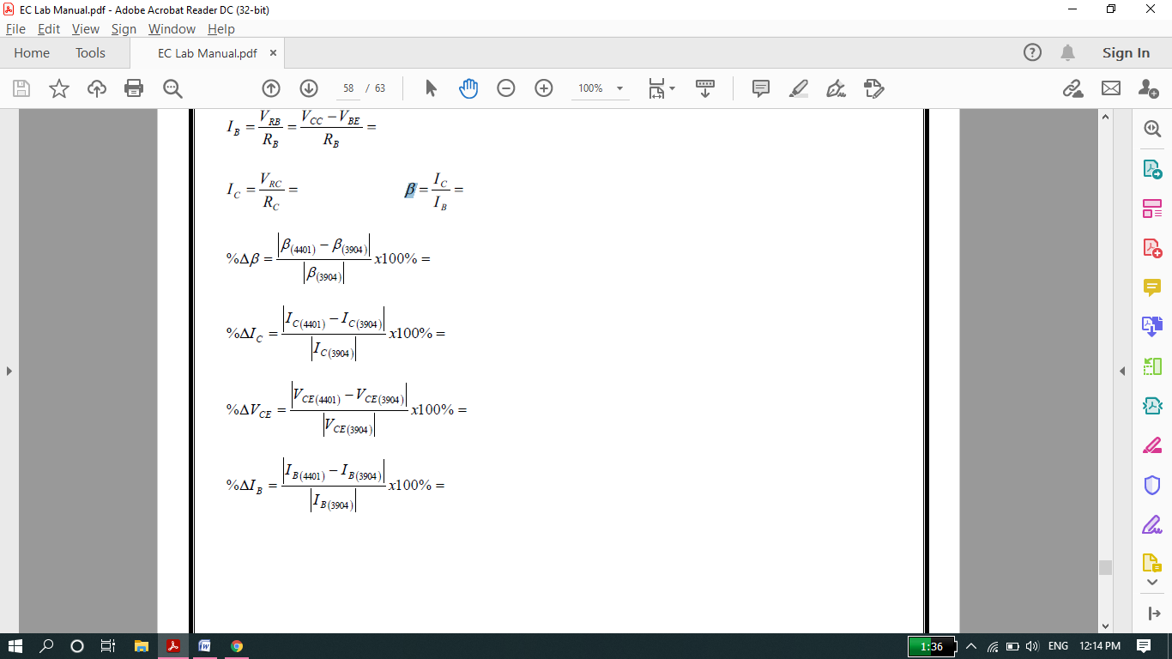

**Calculation:**

* In this lab we will calculate VCE, IB, IC and beta for two different transistor then we will find %error.

**Calculated: Transistor 1(2N2222)**

* IB = 322 μA
* I1=415 μA #I1 and I2 for the verification of Circuit either work or not.
* I2=92.7 μA
* IC = 7.86 mA
* VCC=20v
* VCE = **VCC-Ic(RC+RE)** = 20-7.86 x 10-3(1800+680)

VCE=0.51 V (while Voltmeter value=0.30 nearly same)

* Beta=IC/IB=24.4

**Schematic Circuit:**

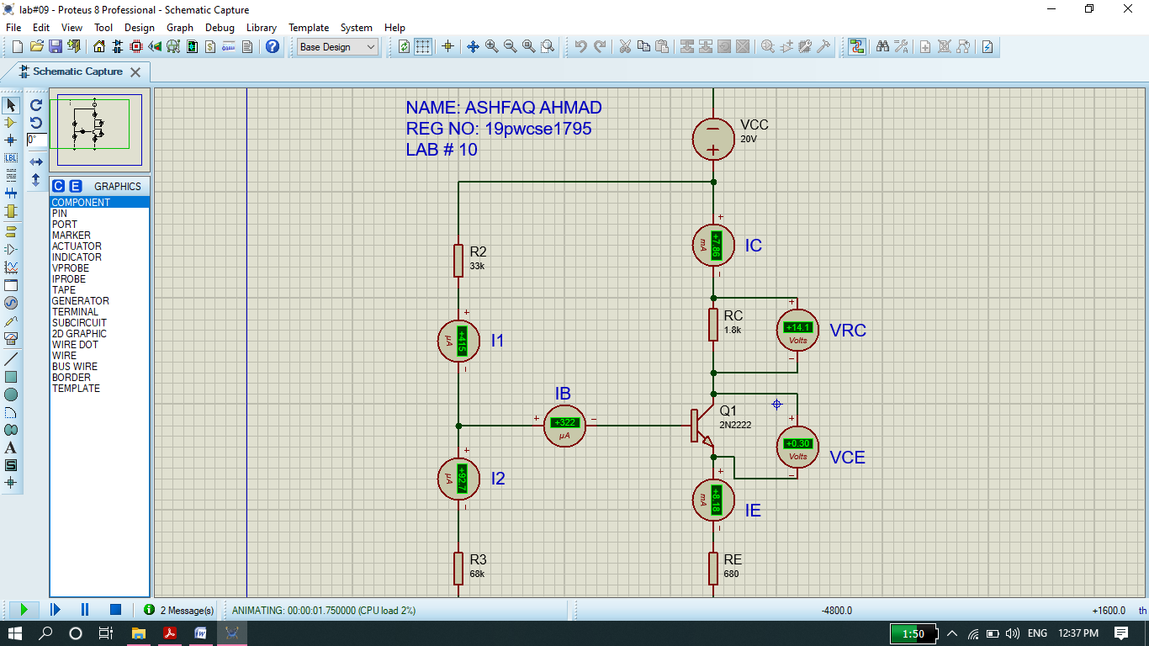

**Calculated: Transistor 2(2N3904)**

(Here no need to verify the circuit again)

* IB = 321 μA
* IC = 7.93 mA
* VCC=20v
* VCE = **VCC-Ic(RC+RE)** = 20-7.93 x 10-3(1800+680)

VCE=0.34 V (while Voltmeter value=0.11 nearly same)

* Beta=IC/IB=24.7

**Schematic Circuit:**

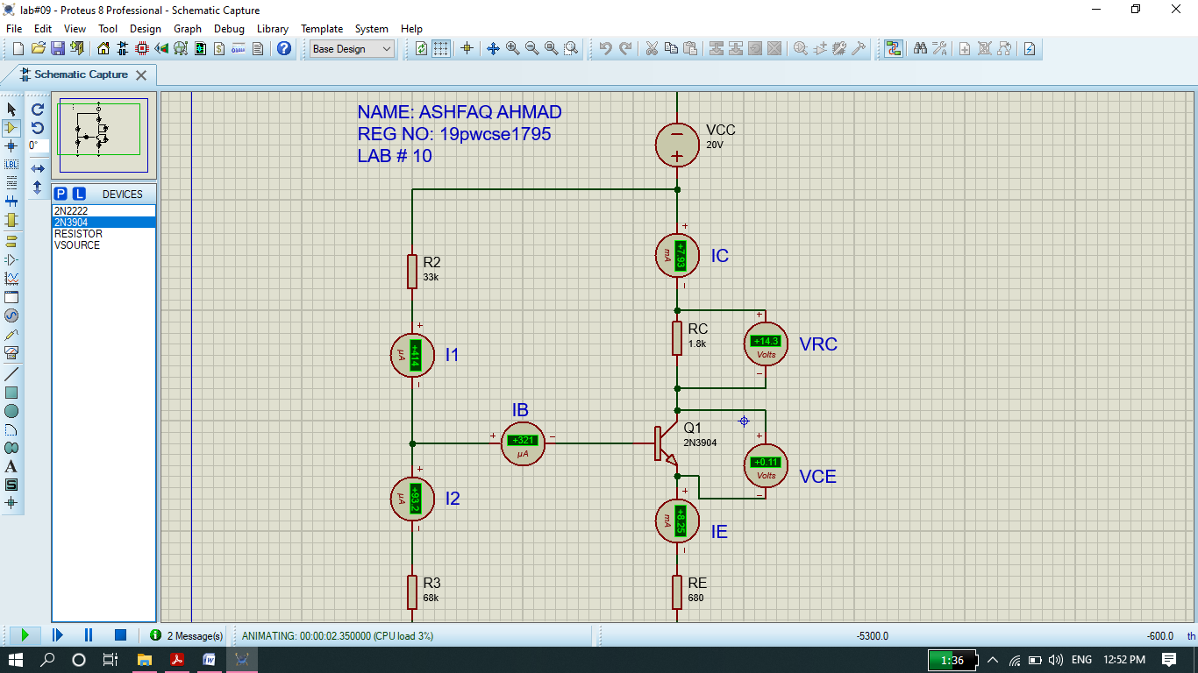

**TABLE:**

|  |  |  |  |  |  |
| --- | --- | --- | --- | --- | --- |
| Transistor-Type | | VCE(V) | IB(μA) | IC(mA) | β |
| 2N2222 | 0.51 | | 322 | 7.86 | 24.4 |
| 2N3904 | 0.34 | | 321 | 7.93 | 24.7 |

**Percentage ERROR in Each Quantity:**

* We will ignore –ive sign of %age error.

